Regulations:
A18

H.T No

Sreenidhi Institute of Science and Technology
(An Autonomous Institution)
Code No: 7C304 Date: 28-Dec-2019 (FN)

B.Tech II-Year I-Semester External Examination, Dec-2019/Jan-2020 (Regular)
PROBABILITY THEORY AND STOCHASTIC PROCESS (ECE)

Time: 3 Hours Max.Marks:70

Note: a) No additional answer sheets will be provided.
b) All sub-parts of a question must be answered at one place only, otherwise it will not be valued.
c) Missing data can be assumed suitably.

Part - A Max.Marks:20

Answer all QUESTIONS.

1. | Consider a telegraph source generating two symbols: dot and dash. The dots were twice as likely to occur as dashes. Find the probabilities of the dots occurring and dash’s occurring? | [2M]
2. | If Y = 4X+5 and X is a uniformly distributed random variable in the interval (-2, 2). Find E[Y]. | [2M]
3. | State Central Limit Theorem for i) unequal and ii) equal distributions | [2M]
4. | State the properties of Auto correlation function. | [2M]
5. | Define mean ergodic process. | [2M]
6. | Relate input and output Power density spectrums of a linear system. | [2M]
7. | What are the conditions to be satisfied by a function to qualify as a Random Variable? | [2M]
8. | What is a joint characteristic function? | [2M]
9. | Define thermal noise. | [2M]
10. | Define Wiener-Khinchine Relations? | [2M]

Part – B Max.Marks:50
ANSWER ANY FIVE QUESTIONS. EACH QUESTION CARRIES 10 MARKS.

11. | a) | Two boxes B1 and B2 contain 100 and 200 transistors respectively. Box B1 has 15 defective transistors and B2 has 10 defective transistors. Suppose one box is selected at random and one transistor is picked at random. What is the probability that it is defective? | [5M]
 | b) | State and explain the laws of probability. | [5M]
12. | a) | A random variable ‘X’ has the following probability distribution  - Evaluate P(X<2) and P(-2<X≤2)  - Find CDF  - Find E[X] | [6M]
  X | -2 | -1 | 0 | 1 | 2 | 3
  P(x) | 0.1 | K | 0.2 | 2k | 0.3 | 3k
 | b) | For what values of ‘β’ is the function f_{X}(x) = (β/x²) u(x-β) a valid probability density function. Find CDF. | [4M]
13. | a) | The Joint probability density function of two random variables X and Y is  f_{xy}(x,y) = C(2X+Y) 0 ≤ X ≤ 1, 0 ≤ Y ≤ 2  Find (i) the value of ‘C’ (ii) marginal distribution functions of X and Y | [6M]
 | b) | If X and Y are two independent random variables and Z = X+Y, relate their mean values m_{X}, m_{Y} and m_{Z}. | [4M]
14. | a) | What is a random process. Classify the random processes. | [4M]
 | b) | A random process is given by X(t) = A Cos(ωt+ϴ), where A and ω are constants and ϴ is uniformly distributed in the interval (0,2π). Find the mean and auto correlation function of this random process X(t). | [6M]
15. | a) | A random process is given as X(t) = At, Where ‘A’ is uniformly distributed random variable in the interval (0, 4). Find whether X(t) is wide sense stationary or not? | [4M]
 | b) | For a stationary ergodic process having the autocorrelation function shown in below fig.  Find (i)E[X(t)] (ii) E[X²(t)] (iii) σ_{x}²  R_{xx}(τ)  50  20  -10 0 10 τ | [6M]
16. | a) | Derive the auto correlation function of response of an LTI system. | [5M]
 | b) | A product device response Y(t) = X(t) A₀ Cos ω₀t, where A₀ and ω₀ are constants.  Find PSD of Y(t) in terms of PSD of input X(t). | [5M]
17. | a) | Consider the experiment of tossing a coin three times. What is the probability that heads appear at the first two tosses. | [3M]
 | b) | Let Y=X². Find f_{Y}(y) if X is N(0,1). | [3M]
 | c) | Let (X, Y) be a bivariate random variable. f(x, y) is the joint Probability Mass function. Find P(X≤ 2, Y ≤ 3).  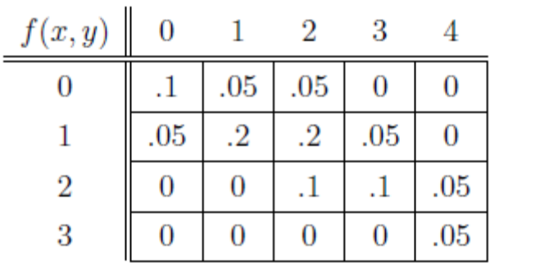 | [4M]
18. | a) | If X(t) and Y(t) are two uncorrelated random processes, what is their cross covariance? | [3M]
 | b) | Find the autocorrelation function corresponding to the power spectrum  ψ_{XX}(ω) = 8/(9+ω²)² | [4M]
 | c) | Define bandpass, bandlimited and narrow band processes. | [3M]

-- 00 -- 00 –

